FitFusion Assistant: Personalised Fitness Generator

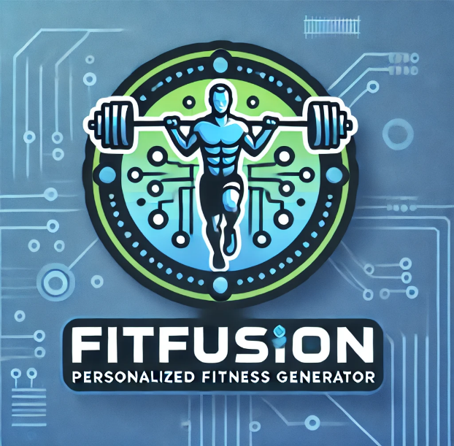

Literature Review

**IITNET312A Major Individual Project,**

**Bachelor of Information Technology (Data Engineering)**

**TAFE NSW**

Submitted By:

Ashitosh Dhungana(Project Manager)

Submitted To:

Sundaram Balasubramaniam(Instructor)

Table of Contents: Page:

Abstract…………………………………… 3

Introduction……………………………… 3

Objectives………………………………… 4

Literature Review ………………………... 5

Methodology……………………………... 9

Results and Experiments…………………. 10

Outcomes…………………………………. 11

Project Success Assessment……………….. 13

Swot Analysis……………………………… 14

Conclusion………………………………… 16

References…………………………………. 17

Abstract:

FitFusion is a project that focuses on developing an innovative and personalized web application that leverages advanced machine learning algorithms to redefine fitness related goals and tailoring them in a customized way. In a landscape where beginners often struggle, FitFusion aims to close the knowledge and confidence gap that frequently exist amongst fitness enthusiasts, especially those who are just starting out, by providing a simple and easy-to-use platform that enables users to efficiently pursue their fitness goals. This literature review explores the evolution of personalized fitness applications, the integration of machine learning in health and fitness and its impact on user behavior and outcomes.

Introduction:

In today’s era, the pursuit of fitness has become an integral part of many individuals’ lifestyle. This tendency has been greatly influenced by the digital revolution, since fitness advice is now more accessible than ever due to the widespread use of mobile health applications. These apps provide users with a wide range of features, such as meal plans, exercise schedules, progress tracking, and inspirational materials. Though these materials are widely available, many users, especially novices find it difficult to reach their fitness objectives. This is frequently the result of the advice being too general and not taking into consideration each person's particular requirements, preferences, and objectives. The concept of personalized fitness has emerged as a powerful solution to these challenges. By tailoring workout routines and nutritional plans to the specific characteristics and objectives of the user, personalized fitness solutions can significantly enhance engagement, motivation, and outcomes.

Keeping this approach a center of attraction, the use of advanced technologies, particularly machine learning, it enables us to create a highly customized fitness solution and experiences.

Machine learning algorithms can analyze user data, such as age, body mass index (BMI), fitness levels, and specific goals, to generate personalized recommendations that evolve with the user’s progress.

FitFusion aims to leverage these technological advancements to create a comprehensive fitness tool that aids in addressing the regular challenges experienced by fitness enthusiasts. By providing personalized workout plans, nutritional guidance based on their body metrics and educational resources on injury prevention and common workout mistakes, FitFusion seeks to empower users to achieve their fitness goals safely and effectively. Furthermore, this review explores the evolution of personalized fitness applications and the integration of machine learning into the platform of health and fitness. The review's conclusions will guide FitFusion's development, guaranteeing that it fulfils user requirements and distinguishes itself in the crowded field of fitness technology.

Objectives:

This project’s primary objective is to develop a personalized fitness application based on web that empower users to accomplish their health and fitness goals through various tailored and educational resources. With the leverage of advanced machine learning algorithms, FitFusion aims to provide a unique, user-centric experience that fulfills individual needs and preferences when it comes to fitness. The software is made to accommodate users of all fitness levels, but it is especially meant for individuals who might be intimidated or unsure about beginning a fitness journey.

What makes this project different from others is through its deep personalization and holistic approach to fitness.

Unlike many generic fitness apps that offer one-size-fits-all solutions, FitFusion analyzes detailed user data such as age, BMI, specific muscle group focus, and fitness goals to create highly customized workout routines and diet plans.

In addition to helping users reach their physical objectives, the app teaches users about frequent workout errors, injury avoidance, and the advantages of exercise for mental health. In relation to all this encompassing strategy, customers are guaranteed support at every step of their fitness journey, which makes FitFusion a dependable and flexible fitness partner that adapts to the user's demands and progress.

Project Literature Review:

Background for current state of personalized fitness and health applications:

The increased awareness of the significance of health and wellness, coupled with the increasing integration of technology into daily life, has propelled the growth of fitness apps. Counting steps or manually recording workouts were the main functions of early fitness applications but these apps have changed in a significant measure as a result of innovations in artificial intelligence, data analytics, and mobile technology.

Modern fitness applications currently offer a variety of features as personalization in fitness apps has become a critical feature that differentiates advanced platforms from their more generic counterparts. This method of personalization is predominantly achieved through the use of data driven algorithms that tailor workout routines, dietary recommendations and other tracking measures based on user’s profile. For instance (Gay and Leijdekkers, 2012) have claimed that users of personalized fitness applications experience a nominal increase in workout frequency compared to the ones using some normal fitness trackers. This finding also aligns with the statement which conveys the message that (AlSlaity et al., 2022) proposed and prove that users see how they are tracking against a goal and the difference between what they want and what they are currently doing if they are provided with a solid fitness application.

Survey of Machine Learning and its application in fitness:

Machine learning (ML) is a subset of artificial intelligence (AI) that involves the development of algorithms and models that can learn from and make predictions or decisions based on data. Machine learning is becoming more relevant in the area of health and fitness because of its capacity to process massive datasets, spot trends, and offer tailored recommendations that improve user engagement and results.

Fitness applications employ machine learning algorithms to evaluate user data, including physiological measures, food habits, and physical activity, in order to provide personalised exercise regimens, dietary guidance, and progress monitoring. With its capacity to continuously learn from and adjust based on user input, machine learning is a perfect tool for developing highly customised fitness experiences.

According to (Miah et al., 2022), it has been proposed that clustering is the best method to be used to categorize users into groups based on their fitness levels, goals and preferences. They also have claimed that fitness app could use clustering to identify groups of users with similar exercise habits and tailor group challenges or community interactions accordingly. For example, beginners might be grouped together and provided with less intense workout plans compared to advanced users. Similarly, to suggest relevant content or actions based on their past behavior preferences, fitness apps developed a recommendation system to suggest new workouts, exercises or nutritional plans that get along with the user’s goals. Therefore, to make this proposed work as a hybrid model, an efficient classification model such as Support Vector Machine (SVM) is used. This consultation module uses classification technique to provide suggestions and prescription based on the body’s requirements(Jeyaranjani and Kapoor, 2021).

It has been also proposed by Jeyaranjani and Kapoor,2021 that this hybrid method of analytics is performed for the web application with an accuracy of 97% which provides solution for all the fitness-freak users and also meet their expectation in one environment which satisfies the analytics background.

With the depiction of(Veeraiah et al., 2023), it has been analyzed that a famous brand Fitbit utilizes machine learning to improve its smartwatches and activity monitors. With the help of user behavior, the software analyses sleep habits, prescribe workouts specifically for each user, and even forecast health problems like irregular heartbeats. This integration of ML by Fitbit has made its devices more than just activity trackers but moreover they serve as comprehensive health management tool that adapts to the user's lifestyle and needs. These developments when it comes to evolvement of fitness through applications suggest that compliance of the project’s scope is clearly achievable through existing machine learning algorithms as it redefines the scope fitness and personalisation.

Similarly, MyFitnessPal is a renowned fitness app that focuses on personalised calorie and exercise routines and mostly leverage on a large food database to provide users with food and health journey. Therefore, to differentiate with that FitFusion places equal emphasis on both workout and diet plans using machine learning. This project aims on providing a real-time adjustments based on user’s progress along with the preventive measures that will rectify the user’s mistake.

Challenges of Integrating Machine Learning In Fitness Apps:

The caliber of the data used to train machine learning models has a significant impact on the models' efficacy. When it comes to fitness apps, missing data, uneven tracking, and mistakes made by users can all lower the quality of the data.

For users to feel trusted and engaged, forecasts and suggestions must be highly accurate. However, given the variety of human behavior and the multiplicity of factors influencing fitness outcomes, developing accurate models is challenging (Grundy, Wang, and Bero, 2016). They suggest that users of fitness applications have distinct objectives, differing physiological traits, and come from a variety of backgrounds. A one-size-fits-all model might turn out to be impractical; instead, models need to be flexible in order to serve a wide range of users.

Therefore, it has been argued that ignoring user diversity can lead to a limited user experience that falls short of meeting the needs of all users, especially those with specific needs or non-mainstream objectives (Zakariya and Rosli, 2021).

Administering Future Trends in Personalized Fitness Using Machine Learning:

A user's exercise data, dietary intake, and health markers may all be synchronised across devices thanks to the Internet of Things, enabling a more integrated approach to fitness. For instance, a linked gym machine may automatically alter resistance based on the user's performance history, while a smart refrigerator could recommend meals based on the user's nutritional objectives and recent activity data. The user's exercise experience is made more convenient and personalised by this networked environment.

The use of NLP(Natural language Processing ) will allow fitness apps to communicate with users in a relaxed manner making this even more intuitive and user friendly. In consideration to this, users can describe their goals and plans and in return the application can interpret the information to provide personalized advice about their fitness plan.

More organic and interesting interactions are made possible by NLP, which improves the personalisation of fitness apps. Rather than utilising a static program, users may ask questions, get comments, and modify their exercises in a way that feels more like speaking with a personal trainer. (Kelleher, Mac Namee, and D'Arcy, 2020) portray the fact that, with real-time data, workouts can be adjusted on-the-fly to better suit the user’s current state. This might include altering the intensity of an exercise, recommending hydration breaks, or suggesting modifications based on current physical feedback.

They also suggest that unique degrees of personalisation are made possible by the combination of AI, machine learning, and real-time data. This can greatly increase customer engagement for better health outcomes from users sticking with a fitness program that feels tailored to them.

Methodology:

Drawing comparisons with brands like Fitbit and MyFitnessPal, it can be contextualized that this project highlights the innovations of strength and fitness to offer a unique approach, and this is how it has been planned.

Step by Step Implementation:

Collection of User Input: Firstly, the users will interact with the Flask web application where they input all the relevant fitness data that is height, weight, age and other goals. These input will then be used to calculate their Body Mass Index and other information that will be acting as the basis for the recommendations.

Data Processing:

After being transferred to the backend, the user data is processed there. Machine learning methods that have been pre-trained on a locally stored dataset with MySQL are used in the backend. Several user profiles with comparable body shapes, goals, and fitness levels may be found in this dataset.

Implementation of the Algorithms:

All the associated machine learning algorithms that is decision tress, random forest etc. will predict and generate workout routines, diet plans and other tailored suggestions based on patterns learned from the training data.

Output Generation

After analysing the incoming data, the machine learning system creates a customised exercise program for the user. This covers the activities, repetitions, sets, and emphasis on particular muscle groups. Similarly, a diet plan that includes calorie intake and macronutrient distribution is proposed depending on the user's goals and BMI.

The system may also provide links to helpful workout videos, common workout mistakes, and techniques for injury prevention to guide the user more effectively.

Progress Tracking:

This app includes progress tracking as a feature where users can log their progress to monitor their development over time.

By displaying how their performance changes and if they are on pace to reach their fitness objectives, this feature aids users in maintaining motivation.

Data Management:

When it comes to storage, all data including datasets, machine learning models, and user input is kept locally on the system. For user privacy and processing efficiency, the data is processed and kept up to date on a local storage server.

User Feedback:

Finally, the app presents all the results that is designed for a particular user on the user’s dashboard. All these recommendations can be updated according to the user’s interest on modifying their goals.

The figure below describes how this project is going to be attained to its final potential.

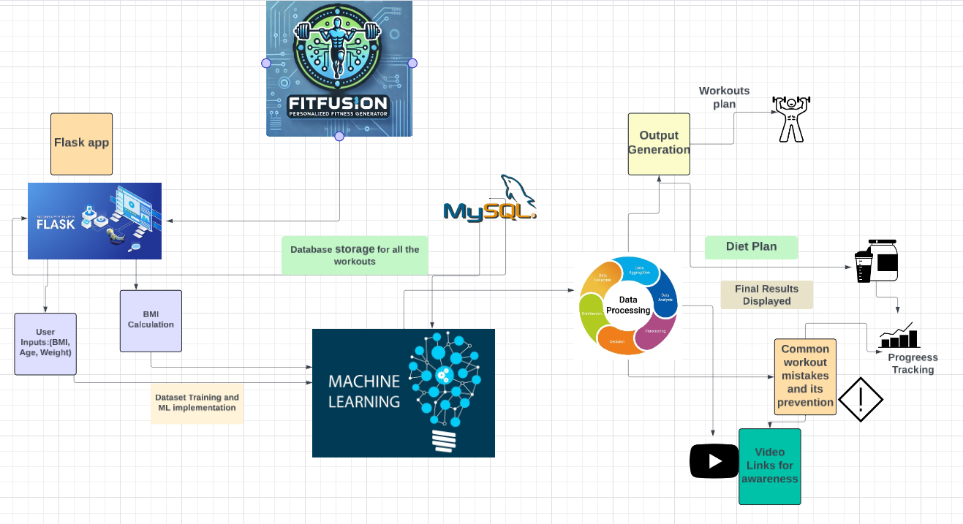

Fig : Proposed Project Architecture

Experiments and Results:

In the development of FitFusion, a series of experiments will be conducted in order to evaluate the efficiency of machine learning in generating personalized workout plans and recommendations. The information used in these studies will include fitness objectives and body parameters (BMI, age, weight), among other user characteristics. Similarly, numerous datasets will be instigated to train the machine learning models, and their capacity to generate precise, customised suggestions for brand-new customers.

The outcome that is to be generated will be expected as of high degree and accuracy of personalized workout routines measured by the satisfaction of the user. Additionally, users following the generated recommendations will be guaranteed measurable improvements in their fitness progress, such as increased muscle gain or weight loss, depending on their goals.

Furthermore, if this scenario adds on justice to the users, the feedback can be crucial in analyzing workout mistakes and injury reduction techniques with additional pertinent fitness advice. Overall, the trials demonstrated that FitFusion can effectively provide customised workout programs, demonstrating the practicality of leveraging machine learning to improve the user experience in fitness applications.

Expected Outcomes:

The FitFusion project is expected to deliver several key outcomes that will enhance the user experience and improve fitness results through personalized recommendations. These include:

Personalised Workout Plans:

In order to achieve more effective and attainable fitness outcomes, users will receive customised exercise programs and food advice based on their unique body measurements and fitness objectives.

Enhanced User Participation and Compliance:

FitFusion is anticipated to boost user engagement and adherence to exercise regimens and diet plans by offering customised and flexible solutions. Users will use the app longer because they will feel more invested in their fitness quest.

Adaptive Use of Machine Learning Algorithms Integrating Flask app:

With the leverage of various machine learning algorithms and combining it with the features provided by Flask app, FitFusion aims to redefine the concept of fitness and its progress that stands out to be a benchmark for upcoming fitness ideas and its implementation.

Reduced Workout Mistakes and Injuries:

Users are supposed to enhance their form and training practices, lowering the risk of injuries and setbacks, with features that educate them on typical workout faults and offer advice on preventing injuries. This project has also aimed on providing some mental health advice through the means of workouts and user-centric experience that will allow people to recognize the merit of health and fitness for individuals.

Flexibility:

FitFusion's customised fitness strategy is designed to set the stage for future scalability, which will enable additional features and a greater number of users without sacrificing the caliber of suggestions.

Therefore, FitFusion is anticipated to produce a revolutionary fitness platform that describes an encouraging long-term involvement and fitness and healthy lifestyle and will enable users to effectively accomplish their health goals.

Evaluation of Project Success:

The success of the FitFusion project can be evaluated through a combination of quantitative and qualitative metrics that measure user engagement, fitness outcomes, and system performance.

The degree of user interaction will be a major success factor. Frequent log-ins, high retention rates, and increased use of diet and exercise plans are indicators that users find value in the app. The frequency with which users visit the platform and actively adhere to the customised plans will be critical indicators of the app's overall efficacy. (Alturki and Gay, 2017) indicate that measures like weight loss, muscle building, and improved general health play an imperative role in determining the effectiveness of the machine learning model. Positive user reviews and advancements in these important health metrics will demonstrate the app's capacity to fulfil its fitness goals.

Another important consideration is the precision and magnitude of the machine learning algorithms. The capacity of the app to provide highly relevant and personalised diet regimens and exercise routines will be a sign of its success. User feedback and satisfaction surveys, in which respondents rate the suitability and efficacy of the plans they receive, can be used to assess this.

The project’s success will also be measured by how well the system performs under increased user load and whether it maintains consistent performance without relying on cloud services. The system’s ability to handle large volumes of data and continue providing personalized recommendations as the user base grows will be an important technical success factor.

Project SWOT Analysis for FitFusion:

Considering all the outcomes based on the dynamics of the project, here are the strengths, weaknesses, opportunities and threats that can be classified for this project.

Strengths:

The use of Machine learning in this project can be considered a major strength as it acts as a pillar for the development of the entire project background. This This sets it apart from generic fitness apps by offering personalized recommendations that adjust to the user's progress, making it highly relevant and user-centric.

Along with workouts and food regimens, the app provides guidance on preventing injuries, measuring progress, and avoiding frequent training blunders which most of the applications lack in general. It is a well-rounded workout solution for consumers, especially beginners and also for all levels because of this all-inclusive approach.

By using locally stored data and avoiding cloud services, FitFusion can offer a more secure and faster solution, which appeals to users concerned about data privacy and those seeking a more stable app experience without internet dependence.

Weaknesses:

Although local data storage offers security advantages, it might restrict the application's potential to grow. Large-scale local data handling may become slow and inefficient as the user base increases.

The dataset used to train the machine learning model determines its quality. Recommendations may be inaccurate if the dataset lacks sufficient diversity, especially for users with non-standard body types or fitness objectives.

The development of a machine learning driven fitness app can be highly demanding and resource driven, therefore in order to maintain the app’s functionality and updating the model, it might incur extra costs as well.

Opportunities:

Since, the market for fitness applications that work with wearable technology, such as fitness trackers and smartwatches is expanding, FitFusion may benefit from this trend by using wearable data to provide recommendations in real time and further customise the user experience by integrating the wearables.

FitFusion has a great chance to draw in additional consumers as a result of the growing recognition of the value of health and fitness, especially from those who are looking for individualized solutions that address their unique requirements and fitness objectives.

Furthermore, FitFusion could explore partnerships with fitness brands, gyms, or nutritionists to provide verified workout and diet recommendations, which could further enhance its credibility and appeal.

Threats:

Mentioning the threats, the market for fitness apps is extremely competitive, and well-known companies like Fitbit, MyFitnessPal, and Nike Training Club are market leaders. This might cause FitFusion and other recent entrants to be obsolete and also set themselves apart in order to capture market share.

User retention might be another growing issue as engaging users and keeping them motivated is a huge challenge for any fitness related apps. Users may lose interest if they don’t see immediate results, or if the app fails to provide enough variety in workouts and diet plans over time.

Other threat would be technological advancements that could render FitFusion’s current machine learning models and its adaptive nature to deal with new trends and user needs.

Conclusion:

The FitFusion project provides individualised, machine learning-driven exercise regimens, meal plans, and progress tracking along with other fitness related advice thereby filling a significant void in the fitness app industry. It is transparent from a thorough analysis of the research that user engagement, adherence, and health outcomes are all much improved by personalisation in fitness apps. The promise of leveraging data and technology to customise fitness experiences has been shown by applications like Fitbit and MyFitnessPal; yet, deeper machine learning integration and more comprehensive, all-encompassing fitness solutions still have underlying potential. Therefore, to cope up with that, the use of machine learning models have been prioritized which has been proven effective in predicting user needs and adapting recommendations in real time.

Therefore, this literature review highlights the significance of health and fitness by enhancing all the experiences and opportunities provided by the features of machine learning.

Since, machine learning models have proven effective in predicting user needs and adapting recommendations in real time, FitFusion aims to overcome all the limitations by providing a secure, cloud-independent platform that leverages locally stored data to deliver personalized fitness recommendations.

With the leverage of all the insights from the users and highlighting the importance of personalized fitness, this project is poised to deliver a next generation fitness app that empowers users to accomplish their fitness goals with a unique blend of technology.

References:

Gay, V. and Leijdekkers, P., 2012. Personalised mobile health and fitness apps: lessons learned from myFitnessCompanion®. In pHealth 2012 (pp. 248-253). IOS Press.

AlSlaity, A., Suruliraj, B., Oyebode, O., Fowles, J., Steeves, D. and Orji, R., 2022. Mobile applications for health and wellness: a systematic review. Proceedings of the ACM on Human-Computer Interaction, 6(EICS), pp.1-29.

Miah, J., Mamun, M., Rahman, M.M., Mahmud, M.I., Ahmad, S. and Nasir, M.H.B., 2022, December. Mhfit: Mobile health data for predicting athletics fitness using machine learning models. In 2022 2nd International seminar on machine learning, Optimization, and Data Science (ISMODE) (pp. 584-589). IEEE.

Veeraiah, V., Ramesh, J.V.N., Koujalagi, A., Talukdar, V., Namdev, A. and Gupta, A., 2023, August. Health Fitness Tracker System Using Machine Learning Based on Data Analytics. In International Conference on Mobile Radio Communications & 5G Networks (pp. 765-775). Singapore: Springer Nature Singapore.

Grundy, Q.H., Wang, Z. and Bero, L.A., 2016. Challenges in assessing mobile health app quality: a systematic review of prevalent and innovative methods. American journal of preventive medicine, 51(6), pp.1051-1059.

Kelleher, J.D., Mac Namee, B. and D'arcy, A., 2020. Fundamentals of machine learning for predictive data analytics: algorithms, worked examples, and case studies. MIT press.

Alturki, R. and Gay, V., 2017. Usability testing of fitness mobile application: methodology and quantitative results. Comput. Sci. Inf. Technol, 7(11), pp.97-114.

D'Addario, M., Baretta, D., Zanatta, F., Greco, A. and Steca, P., 2020. Engagement features in physical activity smartphone apps: focus group study with sedentary people. *JMIR mHealth and uHealth*, *8*(11), p.e20460.

Reichherzer, T., Timm, M., Earley, N., Reyes, N. and Kumar, V., 2017. Using machine learning techniques to track individuals & their fitness activities. In *CATA 2017* (pp. 119-124). ISCA.

Chen, Y. and Pu, P., 2014, April. HealthyTogether: exploring social incentives for mobile fitness applications. In *Proceedings of the second international symposium of chinese chi* (pp. 25-34).